A Major Project On

## BRINGING OLD PHOTOS BACK TO LIFE USING DEEP LEARNING TECHNIQUES

Submitted in partial fulfillment of the requirements for the award of the

## Bachelor of Technology

In

## Department of Computer Science and Engineering

By

|  |  |
| --- | --- |
| **AKURATHI ARAVINDA** | **18241A0561** |
| **CHALLAGULLA YOSHITHA** | **18241A0569** |
| **KAKARLA MEGHANA** | **18241A0580** |
| **KANDULA SREEJA** | **18241A0583** |

Under the Esteemed guidance of

**G. Mallikarjuna Rao, Professor**

**Department of Computer Science and Engineering**

**GOKARAJU RANGARAJU INSTITUTE OF ENGINEERING AND TECHNOLOGY (Approved by AICTE, Autonomous under JNTUH, Hyderabad), Bachupally, Kukatpally, Hyderabad-500090**



**GOKARAJU RANGARAJU INSTITUTE OF ENGINEERING AND TECHNOLOGY (Approved by AICTE, Autonomous under JNTUH, Hyderabad), Bachupally, Kukatpally, Hyderabad-500090**

**CERTIFICATE**

This is to certify that the major project entitled “**Bringing old photos back to life using deep learning technique**” is submitted by **A. Aravinda (18241A0561), CH. Yoshitha (18241A0569), K. Meghana (18241A0580), K. Sreeja(18241A0583)** in partial fulfillment of the award of degree in BACHELOR OF TECHNOLOGY in Computer Science and Engineering during academic year 2021-2022.

INTERNAL GUIDE HEAD OF THE DEPARTMENT

**G. Mallikarjuna Rao Prof. Dr. K. MADHAVI**

(Professor)

EXTERNAL EXAMINER

# **ACKNOWLEDGEMENT**

There are many people who helped us directly and indirectly to complete our project successfully. We would like to take this opportunity to thank one and all. First, we would like to express our deep gratitude towards our internal guide **G. Mallikarjuna Rao, Prof.** Department of CSE for his support in the completion of our dissertation. We wish to express our sincere thanks to **Dr. K. Madhavi, HOD, Department of CSE** and to our principal **Dr. J. Praveen** for providing the facilities to complete the dissertation. We would like to thank all our faculty and friends for their help and constructive criticism during the project period. Finally, we are very much indebted to our parents for their moral support and encouragement to achieve goals.

**A. Aravinda (18241A0561)**

**CH. Yoshitha(18241A0569)**

**K. Meghana(18241A0580)**

**K. Sreeja(18241A0583)**

**DECLARATION**

We hereby declare that the industrial major project entitled **“Bringing Old Photos back to life using deep learning techniques”** is the work done during the period from(**August 2021 to May 2022)** and is submitted in the partial fulfillment of the requirements for the award of degree of Bachelor of Technology in Computer Science and Engineering from Gokaraju Rangaraju Institute of Engineering and Technology (Autonomous under Jawaharlal Nehru Technology University, Hyderabad).The results embodied in this project have not been submitted to any other university or Institution for the award of any degree or diploma.

**A. Aravinda (18241A0561)**

**CH. Yoshitha(18241A0569)**

**K. Meghana(18241A0580)**

**K. Sreeja(18241A0583)**

**ABSTRACT**

Visual impact on human brain will greatly effect human activities. Old memories in terms of photos provide relax and re-energize human life. By viewing at these photographs, we may relive those memories at any time. However, it is natural the quality and visibility of valuable photo memories will get de-graded over the time. Image restoration process helps in approximating the clean, original image from a corrupted or noisy image. Many types of noise, such as motion blur and camera misfocus, make image restoration more difficult. Because image corruption varies in intensity, the difficulty of restoring photographs in real-world applications varies as well. The challenge here is to address numerous degradations intermingled in one old photo, such as structural defects like scratches and dust spots, and unstructured defects like noises and blurriness, to boost our ability to restore old photographs from various defects. Furthermore, manual restoration takes a long time, resulting in a backlog of work. In this regard “ “ we proposed a framework based deep learning approaches which will take care and restore these invaluable assets. The DEEP LATENT SPACE TRANCELLATION architecture is used in our experimentation and tested local data. The results are encouraging and allowing interested researchers to further explore the domain.

**TABLE OF CONTENTS**

|  |  |  |
| --- | --- | --- |
| CONTENTS | | Page |
| No. |
| Title Page | | I |
| Certificate by the Supervisor | | II |
| Acknowledgement | | III |
| Declaration | | IV |
| Abstract | | V |
| Chapter 1: Introduction .................................................................................................... | | 8 |
| 1.1 Rationale .................................................................................................................... | | 9 |
| 1.2 | Goal ....................................................................................................................... | 10 |
| 1.3 | Objective ................................................................................................................. | 10 |
| 1.4 | Methodology ........................................................................................................... | 11 |
| 1.5 | Roles and Responsibilities ...................................................................................... | 18 |
| 1.6 | Contribution of Project ........................................................................................ | 19 |
| 1.6.1 Market Potential ............................................................................................... | | 19 |
| 1.6.2 Innovativeness .................................................................................................. | | 19 |
| 1.6.3 Usefulness ........................................................................................................ | | 20 |
| 1.7 | Report Organization .............................................................................................. | 21 |
| Chapter 2: Requirement Engineering ................................................................................ | | 22 |
| 2.1 | Functional Requirement ........................................................................................ | 22 |
| 2.1.1 Interface Requirement ...................................................................................... | | 22 |
| 2.2 | Non-Functional Requirements .............................................................................. | 22 |
| Chapter 3: Analysis & Design ........................................................................................... | | 23 |
| 3.1 | Use-case Diagrams ............................................................................................... | 23 |
| 3.2 | Activity Diagrams ................................................................................................. | 24 |

|  |  |  |  |
| --- | --- | --- | --- |
| 3.3 | Class Diagram…………………………………………………………………... | | 25 |
| 3.4 | Sequence Diagram……………………………………………………………… | | 26 |
| 3.5 | System Architecture ............................................................................................. | | 32 |
| Chapter 4: Construction .................................................................................................... | | | 33 |
| 4.1 | Implementation ..................................................................................................... | | 33 |
| 4.2 | Implementation Details ........................................................................................... | | 33 |
| 4.2.1 | | Deep Latent Space Translation......................................................................... | 34 |
| 4.2.2 | | PIL, PyTorch……........................................................................................... | 35 |
| 4.3 | Software Details .................................................................................................... | | 36 |
| 4.4 | Hardware Details ................................................................................................... | | 36 |
| 4.5 | Testing ................................................................................................................... | | 37 |
| 4.5.1 | | White Box Testing ........................................................................................... | 37 |
| 4.5.2 | | Black Box Testing ....................................................................................... | 38 |
| Chapter 5: Conclusion and Future scope ....................................................................... | | | 39 |
| 5.1 Conclusion ........................................................................................................... | | | 39 |
| 5.2 Future Scope........................................................................................................ | | | 40 |
| 5.3 Expected Outcome .............................................................................................. | | | 41 |
| References………………………………………...………………………………….… | | | 43 |

**CHAPTER -1**

**INTRODUCTION**

Machine learning is a type of computer algorithm that learns from examples rather than being explicitly programmed to do a task. Machine learning is the foundation of artificial intelligence. Depending on the structure and complexity of the algorithm, it can be further separated into shallow and deep learning. Image processing has permeated every area of today's technologically advanced culture in the last two decades. Medical imaging, machine vision, remote sensing, and astronomy are just a few of the specialized disciplines where it can be used. A range of specialist image processing algorithms can quickly edit personal photographs acquired by various digital cameras. Image restoration can be thought of as a crucial aspect of image processing. The main goal is to improve the quality of an image by removing flaws and making it more appealing.

To rescue ancient photos that have been extensively deteriorated, we recommend employing machine learning and deep learning. Image restoration is the process of computing the clean, original image from a corrupted/noisy image. Because image corruption varies in intensity, the difficulty of restoring photos in real-world applications will also differ substantially. Motion blur, noise, and camera mis-focus are examples of corruptions. Image restoration is accomplished by reversing the procedure that blurred the image. Two variational autoencoders (VAEs) will be trained to translate old and clean photos into two different latent spaces. Furthermore, in order to improve the ability to restore ancient images with multiple problems, we must handle several degradations intermingled in one old photo, such as structured defects like scratches and dust spots, as well as unstructured defects like sounds and blurriness. We could also employ a different face refining network to retrieve minute characteristics of faces in old photographs, resulting in higher-quality images.

Image restoration is the process of restoring an image from a degraded form, usually a blurred and noisy image. Image restoration is a fundamental problem in image processing that can also be used to examine inverse problems in general. The quality of the recovered image, the computational efficiency of the technique, and the estimate of necessary parameters such as the point-spread function (PSF) to restore the image information lost due to the blurring process are all key factors to consider.

Image enhancement varies from image restoration in that the latter aims to highlight aspects of the image that appeal to the viewer rather than necessarily presenting accurate data from a scientific standpoint. Imaging software's image enhancement approaches do not rely on an a priori description of the process that created the image (such as contrast stretching or de-blurring via a closest neighbour procedure). A colour image is captured first, then converted to grayscale in this project. The picture degradation model is then used to apply the motion blurring effect to that image. The a and b components of the model can be used to change the blurring effect. MATLAB programming is then used to apply random noise to the image. There are a variety of approaches for restoring noisy and motion blurred photos, and inverse filtering and wiener filtering are employed in this study. As a consequence, using inverse filtering and wiener filtering techniques, both motion blurred and noisy motion blurred images are reconstructed, and a comparison is made.

**Rationale:**

Image restoration aims to "undo" or "compensate" for faults in an image that cause it to be damaged. Degradation includes things like motion blur, noise, and camera misfocus. It is possible to approximate the genuine blurring function in some cases, such as motion blur, and then "undo" the blur to recover the original image. The best we can expect for when an image is tainted by noise is to compensate for the quality loss it has caused. In this project, we will introduce and apply a variety of image restoration methods used in the image processing industry.

The elimination or reduction of degradations that occur during the capture of images, such as noise, pixel value errors, out of focus blurring, or camera motion blurring, using prior knowledge of the deterioration phenomenon, are the main problems of image restoration. This indicates that it is concerned with the modelling of degradation and the use of the inverse process to recreate the image. Image restoration can be used in a variety of ways.

**Objective:**

Our image restoration model's goal is to:

• Pre-process data

• Determine the type of noise

• Apply the appropriate image restoration techniques

• Reduce noise in photos and restore them

**Goal:**

The goal of our model is to:

* Identify type of noise
* Apply image restoration techniques

## Methodology

* + 1. **Machine learning**
    2. Machine learning is the process of automatically recognizing meaningful patterns in data. Over the previous few decades, it has become a popular approach in almost every activity that requires information extraction from large data sets. Anti-spam software learns to filter our email messages, and credit card transactions are protected by software that learns to recognise frauds. Machine learning is used in a variety of scientific domains, including bioinformatics, medicine, and astronomy. A common feature of all of these applications is that, unlike more typical uses of computers, a human programmer cannot provide an explicit, fine-grained prescription of how such operations should be carried out in these circumstances due to the intricacy of the patterns that must be identified. As intelligent beings have demonstrated, many of our skills are obtained by learning from our experiences (rather than following explicit instructions given to us). Machine learning technologies are intended to allow programmers to learn and adapt to new situations.

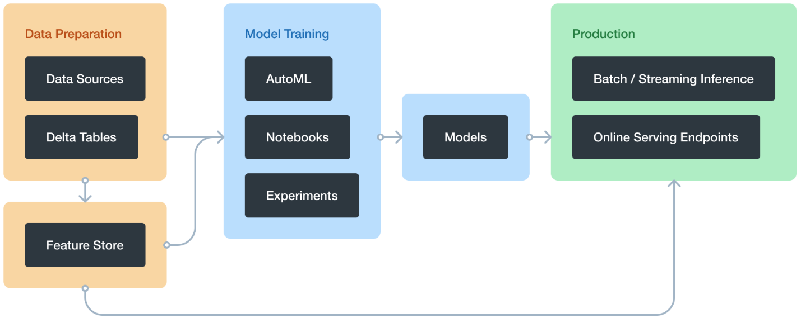

**Fig.1.1**

Deep learning (DL) is a machine learning technique that allows computers to perform classification tasks on images or non-visual data sets by simulating the human brain. Due to advancements in GPU technology, deep learning has recently become an industry-defining tool.

Deep learning approaches extract visual attributes from groups of photos, making them suitable for image denoising and restoration. Deep neural networks, in fact, take advantage of the availability of large amounts of data as well as the automatic learning process to surpass standard image restoration methods. For picture restoration, deep neural networks have recently been constructed.

Deep learning makes use of neural networks to research beneficial representations of capabilities at once from data. For example, you could use a pretrained neural community to discover and eliminate artifacts like noise from images. A self-riding car slows down because it strategies a pedestrian crossing. A deep neural community combines more than one non-linear processing layers, the usage of easy factors running in parallel. It is stimulated via way of means of the organic worried system, and includes an enter layer, numerous hidden layers, and an output layer. The layers are interconnected through nodes, or neurons, with every hidden layer the usage of the output of the preceding layer as it enters.

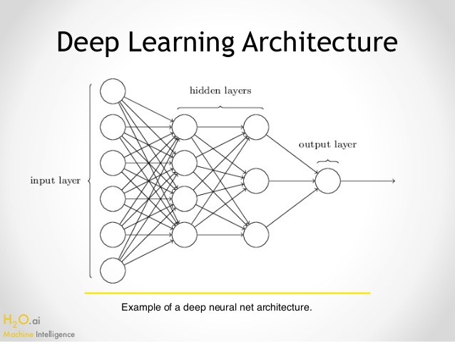

**Fig.1.2**

## Inputs

We have given our inputs consisting of degraded images. There are two types of degraded images i.e., images degraded due to structured defects like scratches and images degraded due to unstructured defects like noise or blur images. We have collected a set of 8 images and saved them under the folder old that are filled with noise and are sent as input to deblur function. We have also collected a set of 4 images which are filled with structured defects i.e. scratches and saved them under the folder old_w_scratch. Together these two sets of images are saved in a single folder i.e. test images. This folder will be uploaded as input to our model where the respective images in the folders with defects will be restored.

The images with noise are:

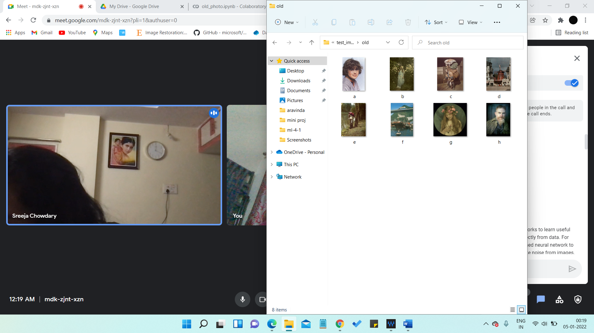

The images with scratches are:

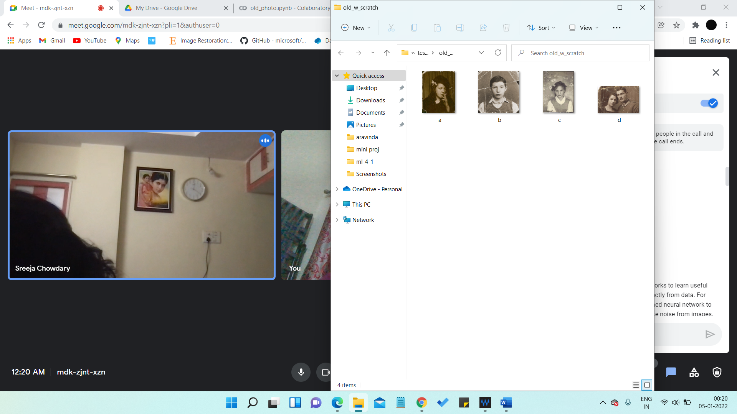

## Preprocessing

We have to preprocess the data before sending the images directly as input to our model. Firstly, we check if the given input is of “png” or “jpeg” format and convert them to the format that can be understood by the computer i.e., the images will be converted into matrix format. If the given image is not of the required format, then we display an error message saying that the image was too large to be converted into matrix format.

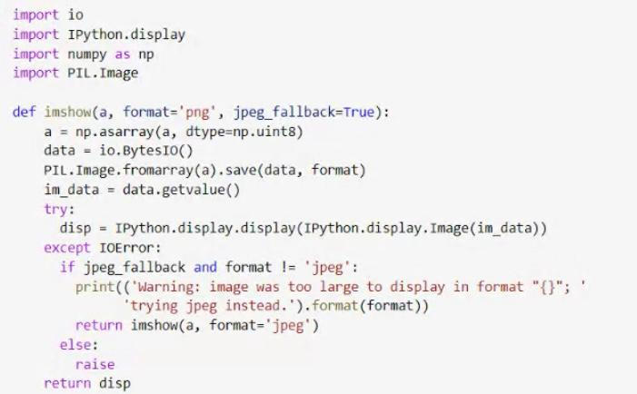

**Fig.1.3**

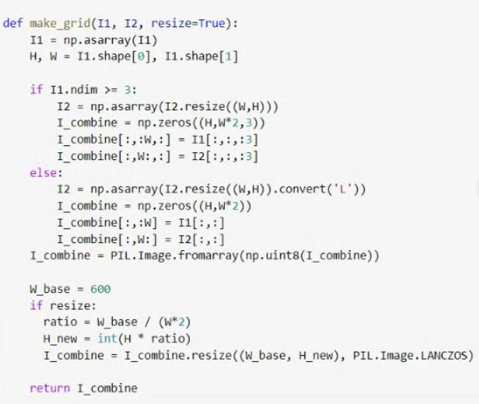

**Fig.1.4**

**Methodology**

The picture restoration model is explained in this project. Images can be harmed in a variety of ways. This degeneration can manifest itself in a variety of ways, including noise, blur, scratches, and the loss of a few components, among others. The degree of degradation varies between photographs. As a result, recovering damaged photos is a difficult task. The proposed system consists of the following stages.

**Fig.1.5**

1. Image acquisition

The system receives the input image in this section.

1. Pre-processing

Pre-processing is the initial step in the image processing process. The image is processed using standard procedures at this point.

1. Denoising

Noise reduction aims to minimise noise in natural pictures while keeping original features and enhancing the signal-to-noise ratio (SNR).

1. Deep latent space translation

Two Variational Autoencoders (VAEs) are trained to turn old and clean pictures into two latent spaces.

VAE1 is trained for pictures in real photos r R and synthetic images x X, while VAE2 is trained for clean images y Y. Images are converted to compact latent space using VAEs. The mapping then uses a partial non-local block to restore the corrupted (blurry, noisy, damaged) images to clean ones in the latent space. The primary goal of this initiative is to bridge the gap between data and authentic historic photographs.

We train two variational autoencoders (VAEs) to transform and clean old pictures into two latent spaces. Synthetic paired data is used to learn the translation between these latent areas. As a result, the learned network can generalise effectively to real-world images.

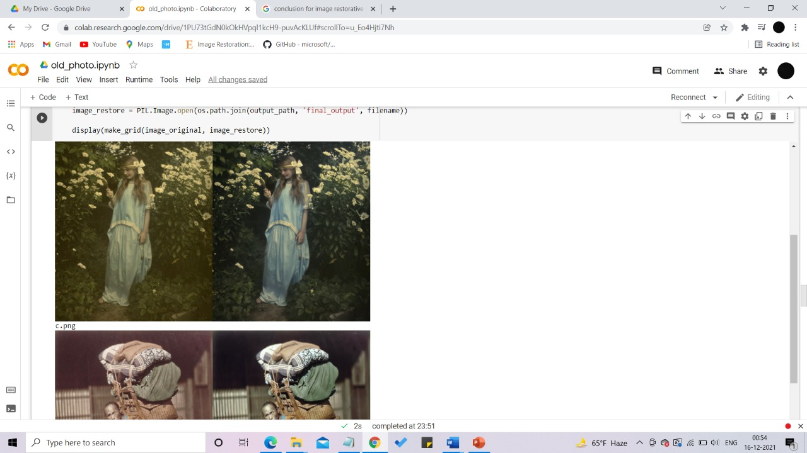

Fig 1: Left image is the input image and right is the restored image

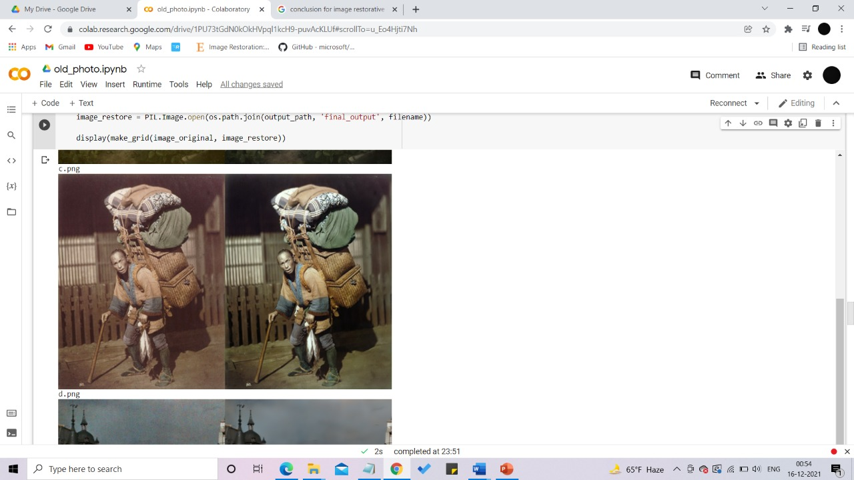

Fig 2: left image is the input image and right is the restored image

## Role and Responsibilities

|  |  |
| --- | --- |
| * 1. **Name** | * 1. **Roles and responsibilities** |
| * 1. **A. Aravinda** | * Literature survey * Coding * Research paper * Machine learning * Data Analysis |
| * 1. **CH. Yoshitha** | * Research paper * Coding * Documentation * Machine learning * Data Analysis |
| * 1. **K. Meghana** | * Literature survey * Data preprocessing * Documentation * Data Analysis * Machine learning |
| * 1. **K. Sreeja** | * Research paper * Documentation * Data preprocessing * Data Analysis * Machine learning |

* 1. **Contribution of Project**
     1. **Market potential**

Image restoration is a type of image processing that has a lot of applications in the field of computer vision. It's a computer technology that uses the damaged image's residual image information to calculate the image information of the damaged area and performs automatic repair. In the year 2000, Bertalmio et al. developed the concept of picture restoration technology for the first time. Image restoration technology has increased in practical significance as a result of technological advancements, propelling image restoration research and application forward. As a result, image restoration has become a hotbed of computer graphics and computer vision research.

With the emergence of deep learning, researchers are dedicated to the investigation of image repair algorithms based on convolutional neural networks and generate antagonistic networks in order to improve the repair impact and strengthen the limitations of standard algorithms in content repair.

In numerous fields from planetary era to molecular spectroscopy and scientific imaging to satellite tv for pc television for computer imaging, the problem in getting higher original pic from blurred and noisy pic is demanding. Digital photograph recovery is being applied in numerous exclusive programs la Just to name a few. recovery has been used withinside the challenge of Astronomical imaging, medical imaging, Restoration of developing older and deteriorated films (Motion photo recovery), Defense and Investigation and Phonons programs. Ancient methods to restore Images adopted one dimensional signal processing algorithms to photograph. Several techniques are proposed which is probably applied in various programs accordingly.

## Innovativeness

From conventional non text-based picture restoration technology to text-based image restoration technology to the present deep learning-based image restoration technology, the notion of image restoration has been advocated since 2000. At this time, digital image restoration technology has made considerable progress in terms of theory and practical application, but it still has several flaws that need to be addressed. Even though deep learning allows for picture restoration without PS traces, there is still a significant barrier in acquiring the image repair region. The algorithm cannot identify the area that needs to be corrected on its own. As a result, we provide the concept of deep latent space translation.

## Usefulness

Many more applications make use of digital picture restoration technology.

1. Image super-resolution analysis (SR): Image super-resolution analysis (SR) is a technique for reconstructing high-resolution images using low-resolution images as a template. Image interpolation methods such as spline interpolation, zero order retention, bilinear interpolation, and others are common. The high frequency components of the original image, however, cannot be reproduced by interpolating merely one image due to the complexity of the image signal. At this point, image restoration technology can be employed to convert the low-resolution points to high-resolution values, and then apply human vision guidelines to fix the remaining areas.
2. Image coding and compression: Most image compression algorithms use transformation plus entropy coding at the moment. Discrete cosine transform, fractal transform, wavelet transform, and other transformations are among the most common. When a picture is compressed, the restoration method can only encode a portion of the image information, leaving the rest to be reconstructed. To improve image quality and coding efficiency, this method makes use of human visual redundancy. This method makes use of human visual redundancy. This method makes use of human visual redundancy to increase image quality and coding efficiency.
3. Error concealment in picture and video transmission: Video transmission is prone to packet loss. To handle blocks with faults, image repair technology is used. Video quality can be improved and secret messages can be encoded in video without changing the transmission bandwidth or communication protocol.
4. Expand the view and create a virtual scene: Panoramic splicing with image fusion technology can expand the view of image browsing, extend the image from the boundary using image restoration technology, perform image roaming, and edit online references from the Internet and large image databases using scene restoration.
5. Picture steganography: The secret image generates normal and independent images with meanings that are different from the secret image. The created image is then given to the recipient, who feeds it into the generated model database, which creates another image that looks exactly like the secret image. This approach has a lot of capacity, security, and consistency. With the improvement of image restoration technology, a new challenge has arisen realistic computer-generated visuals can be forged into photographic images, posing serious security risks. Deep neural networks are capable of detecting photographic images as well as computer-generated graphics.

## Report Organization

The remaining section of the report is structured as follows:

* **Chapter 2** provides detailed business and technical requirements
* **Chapter 3** provides analysis and design of this project
* **Chapter 4** provides Construction, implementation details of this project
* **Chapter 5** provides Conclusion and future scope as well as future application of this project

# **Chapter-2**

# **REQUIREMENT ENGINEERING**

* 1. **Functional Requirement**
  2. A purposeful requirement describes a feature of a machine or its component in software program engineering and structures engineering, where a feature is defined as a definition of conduct among inputs and outputs. Calculations, technical details, statistics manipulation and processing, and other distinctive capabilities that define what a machine is designed to do are all examples of functional requirements.

## Non-Functional Requirement

Non-functional Requirements (NFRs) group together security, reliability, performance, maintainability, scalability, and usability to describe device qualities. Throughout the outstanding backlogs, they have limits or rules on the device's format. Non-functional requirements, often called as device characteristics, are just as important as realistic Epics, Capabilities, Features, and Stories. They assure the device's overall usefulness and efficacy. Failure to meet any of them can result in systems that do not meet internal company, user, or market needs, or that do not meet mandatory requirements enforced through the use of regulatory or other agencies' resources. Noncompliance might result in serious jail time in several situations (privacy, security, safety, to name some).

# **Chapter-3**

## ANALYSIS AND DESIGN

**Use case diagram:**

In UML, use-case diagrams are used to illustrate a system's behaviour and to keep track of its requirements. Use-case diagrams show the high-level functions and scope of a system. These diagrams also show the interactions between the system and its actors. Use cases and actors indicate what the system does and how the actors interact with it via use-case diagrams, but not how the system works internally.

Use-case diagrams describe and define the environment and requirements of a whole system or specific system components. A complicated system can be modelled using a single use-case diagram, or the system's components can be modelled using multiple use-case diagrams. Use-case diagrams are frequently prepared early in the project and referenced to throughout.

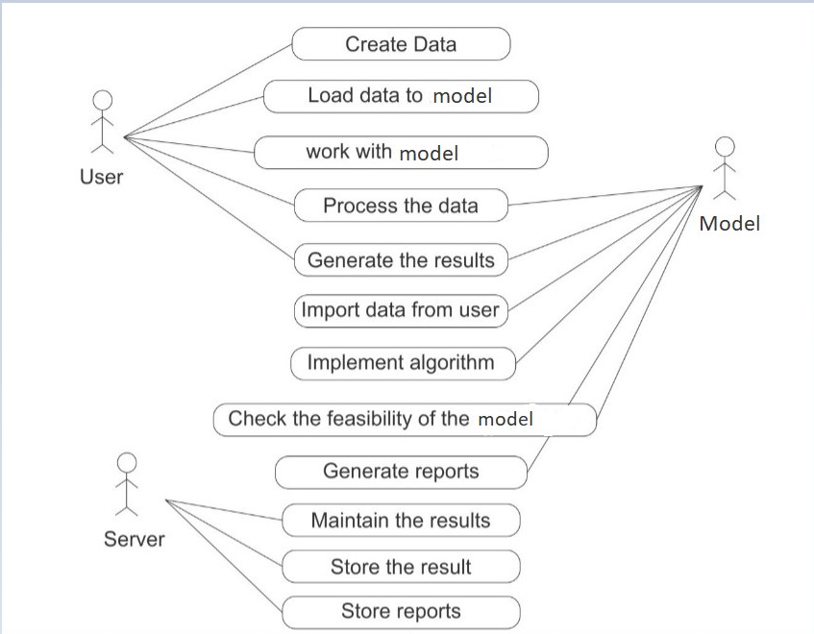

**Fig3.1: Use case diagram for our model**

* 1. **Activity diagram:**

An activity diagram displays the control flow from beginning to end, illustrating the numerous decision paths that exist during the activity. Both sequential and concurrent processing of tasks can be depicted using an activity diagram. They're frequently used in business and process modelling to depict a system's dynamic properties.

An activity diagram and a flowchart are very similar.

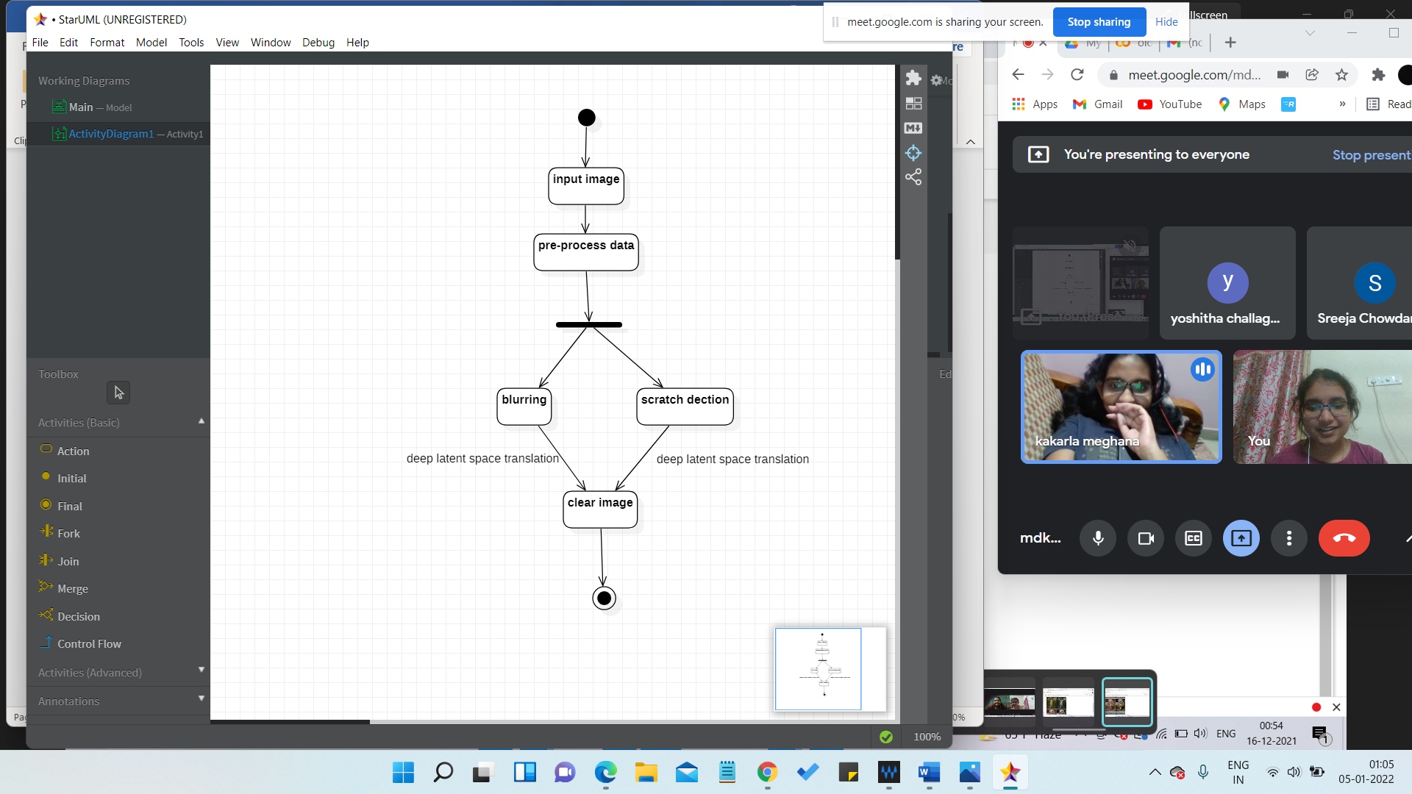

**Fig:3.2: Activity diagram for our model**

**Class diagram:**

A class diagram is another name for a static diagram. It displays an application's static view. A class diagram can be used to visualise, explain, and document numerous parts of a system, as well as to generate software programme executable code.

A class diagram depicts a class's characteristics and activities, as well as the system's limitations. Because class diagrams are the only UML diagrams that can be directly mapped with object-oriented languages, they are frequently employed in the modelling of object-oriented systems. A class diagram shows a group of classes, interfaces, affiliations, collaborations, and constraints.

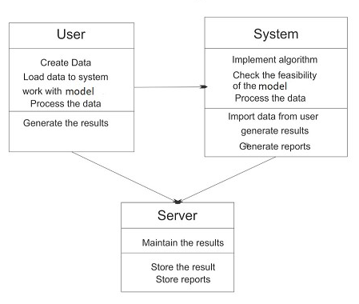

**Fig:3.3: Class diagram for our model**

**Sequence diagram:**

A sequence diagram, also known as a system sequence diagram (SSD), displays object interactions in temporal order in the field of software engineering. It depicts the scenario's objects as well as the sequence of messages that must be passed between them in order for the scenario's functionality to be realised. Sequence diagrams are generally paired with use case realisations in the logical view of the system under development. Other titles for diagrams include event diagrams and event situations.

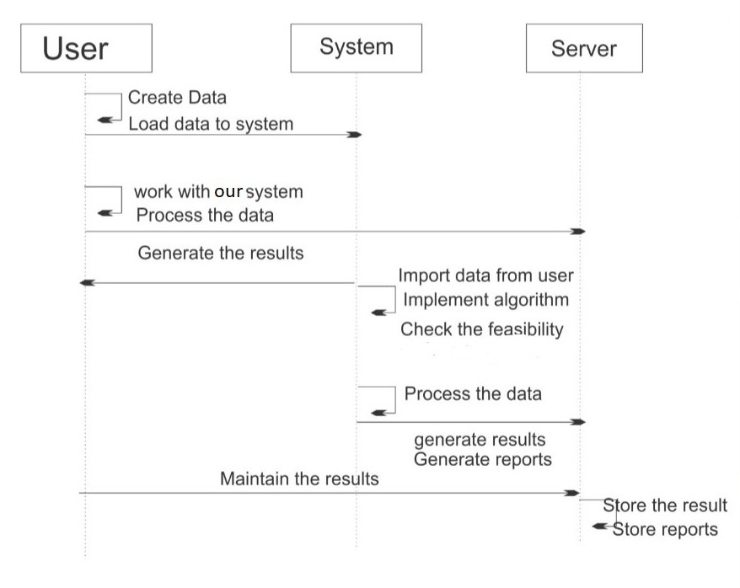

**Fig 3.4: Sequence diagram for our model**

**Collaboration diagram:**

A collaboration diagram, also known as a communication diagram in the Unified Modelling Language, displays the connections and interactions between software components (UML). These diagrams can be used to show the dynamic behaviour of a certain use case as well as clarify the purpose of each object.

The structural pieces required to carry out the functionality of an interaction are first identified before creating a collaboration diagram. The relationships between those pieces are then used to create a model. Software for producing and editing collaboration diagrams is available from a number of providers.

A class diagram shows a group of classes, interfaces, affiliations, collaborations, and constraints. A structural diagram is another name for it.

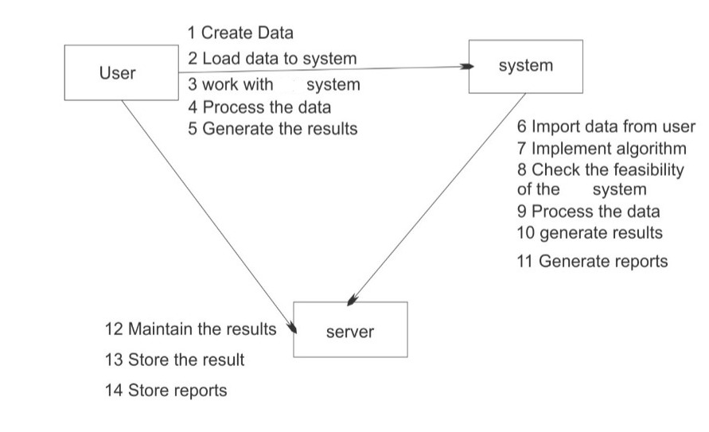

**Fig:3.5: Collaboration diagram for our model**

**Data Flow diagram:**

A data flow diagram (DFD) depicts the flow of data within a system or process. It depicts data inputs, outputs, storage locations, and pathways between each destination using preset symbols such as rectangles, circles, and arrows, as well as short text labels. Data flowcharts can range in complexity from simple, even hand-drawn process overviews to multi-level, in-depth DFDs that go deeper into data processing. They can be used to test an existing system or to create one from scratch. A DFD, lik

A DFD, like the best diagrams and charts, can graphically "communicate" concepts that are difficult to describe in words to both technical and nontechnical audiences, ranging from developers to CEOs. Because of this, DFDs have remained popular over time. They're good for showing data flow software and systems, but they're not so good for interactive, real-time, or database-oriented software and systems in today's environment.

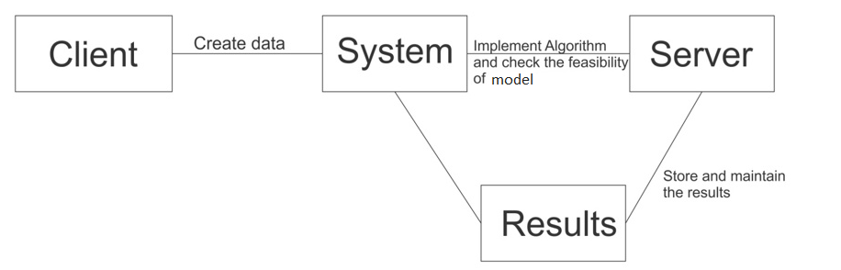

**Fig:3.6: Data flow diagram of our model**

**Component Diagram:**

A component diagram is a sort of diagram in UML. The goal also stands out from the rest of the diagrams. It is the components that enable the system's functionality, not the system's functionality. From that standpoint, component diagrams are used to visualise the physical components of a system. Examples include libraries, packages, files, and other components.

Component diagrams can be used to show a system's static implementation perspective. Static implementation represents the structure of the components at any given time. Because a single component diagram is insufficient to describe the entire system, a collection of diagrams is used.



**Fig:3.7: Component Diagram of our model**

**Statechart diagram:**

The statechart diagram is one of the five UML diagrams used to illustrate the dynamic nature of a system. They specify various states of an entity over the course of its existence, and events change these states. Statechart diagrams are useful for modelling reactive systems. A system that reacts to external or internal events is referred to as a "reactive system." A statechart diagram depicts the transition of power from one state to the next. A state is a state in which an item exists and changes as a result of an event. A Statechart diagram's main purpose is to depict an object's life cycle from creation to end.

Statechart diagrams can also be used to perform forward and reverse engineering on a system. However, the main purpose is to replicate the reactive system.

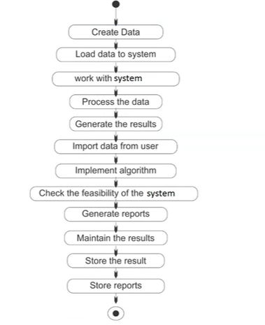

**Fig:3.8: Statechart diagram of our model**

**Deployment diagram:**

A deployment diagram is a type of UML diagram that illustrates a system's execution architecture, with nodes such as hardware or software execution environments and the middleware that connects them. The actual hardware and software of a system are typically depicted using deployment diagrams. Unlike other UML diagram types, which are used to represent a system's logical components, deployment diagrams are used to show the hardware topology of a system.

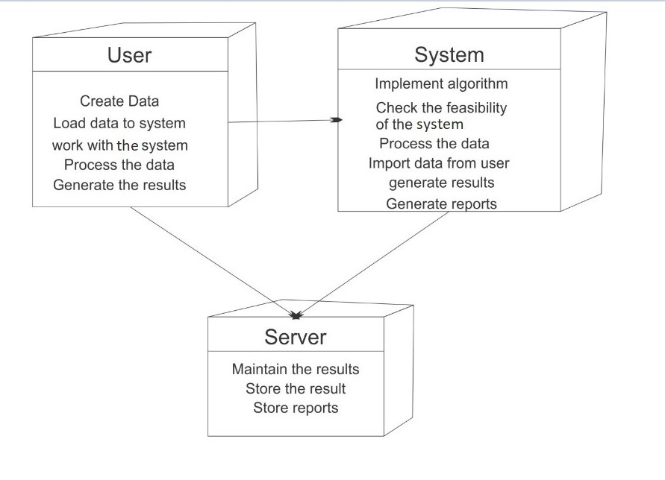

**Fig:3.9: Deployment diagram of our project**

* 1. **System architecture**

A device structure is the conceptual version that defines the structure, behaviour, and greater perspectives of a device. A structure description is a proper description and illustration of a device, prepared in a manner that helps reasoning approximately the systems and behaviours of the device. A device structure can encompass device additives and the sub-structures developed, on the way to paintings collectively to enforce the general device. There were efforts to formalize languages to explain device structure, together those are referred to as structure description languages (ADLs).

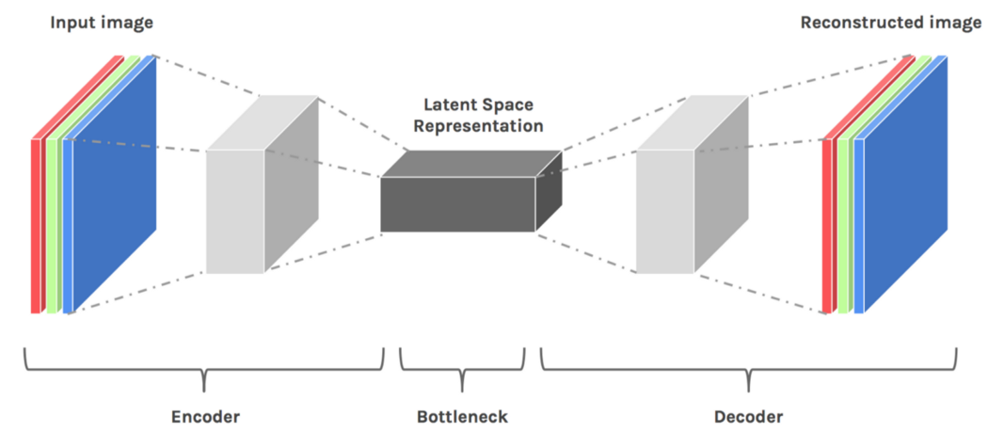



**Fig.3.10: System architecture of our model**



In Figure 3.10, We can see that the incoming image (png format) is converted to a grey scale image at first. The image is then transmitted to an encoder, which compresses it using lossless compression, removing all unnecessary data (such as noise, blur, and so on) and focusing only on the crucial pixels. After that, the image is transferred to a decoder, which enlarges it to its original size while storing the crucial pixels. We will receive the reconstructed image without any degradations in the end.

**Chapter-4**

**CONSTRUCTION**

* 1. **Implementation**
  2. The field of digital image processing encompasses not only the extraction of features, picture analysis, and image restoration, but also image augmentation, filtering, and restoration. Image restoration is a fundamental processing step that entails making specific enhancements to a digital image based on a set of established criteria. The primary goal of restoration is to build or reconstruct a picture that has been deteriorated based on some prior knowledge about image degradation occurrences. The restoration process is objective in nature, in that it seeks to achieve a certain goal, such as removing noise and scratches from an image using a denoising and inpainting function, respectively. The approaches employed in picture restoration can be expressed in either the spatial or frequency domain. The restoration of images is based on probabilistic image degradation models. As a result, picture restoration tends to improve the appearance of the photographs.
  3. **Deep Latent Space Translation:**

Two variational autoencoders (VAEs) have been trained to transform old and clean images into two latent spaces.

VAE1 is trained to recognize images in actual photos r € R and synthetic images x € X, whereas VAE2 is trained to recognize images in clean images y € Y. VAEs are used to transform images to compact latent space. Two VAEs (variational autoencoders) are used to train the framework: Images are converted to compact latent space using VAEs. The mapping then restores the corrupted (blurry, noisy, damaged) images to clean ones in the latent space using a partial non-local block. The initiative's main purpose is to close the gap between data and accurate historical photos. We train two variational autoencoders to translate and clean ancient pictures into two latent spaces (VAEs). The translation between these latent areas is learned using synthetic matched data. As a result, the learnt network may generalise to real-world images successfully.

* 1. **PIL (Python Imaging Library):**

Python Imaging Library is the de facto image processing package for Python (extension of PIL). It includes a set of lightweight image processing tools for editing, creating, and saving photos. The Python Imaging Library was deprecated in 2011, but a project named pillow forked the original PIL project and added support for Python3.x. Pillow has been announced as a replacement for PIL in the future. Pillow supports a variety of image file formats, including BMP, PNG, JPEG, and TIFF. The library invites users to create new file decoders in order to support newer formats.

The Python Pillow module is based on PIL (Python Image Library). It is one of the most important Python modules for image processing. However, Python 3 does not support it. However, we may use this module as a PIL with Python 3.x. It can handle a variety of image formats, including jpeg, png, bmp, gif, ppm, and tiff.

PIL is the foundation for the Python Pillow module (Python Image Library). It's one of the most significant Python image processing modules. Python 3 does not, however, support it. With Python 3.x, however, we can utilise this module as a PIL. Jpeg, png, bmp, gif, ppm, and tiff are among the image formats it can handle. We can do anything with the digital images by using the pillow module. In the next section, we'll learn how to filter photos, make thumbnails, merge images, crop images, blur an image, resize an image, add a watermark, and perform a variety of other tasks. The image is displayed using the image class from the Python pillow library. The pillow package's image modules contain a few built-in functions, such as loading and producing new images.

**PyTorch:**

PyTorch is a tensor library designed for use in Deep Learning applications on GPUs and CPUs. It's a Python-based open-source machine learning tool that was primarily developed by the Facebook AI Research team. Along with TensorFlow and Keras, it's one of the most popular machine learning libraries. The PyTorch library is more popular than TensorFlow and Keras, as shown in this snapshot from Google Search Trends. PyTorch is a Python and Torch-based tensor computing framework that performs tensor computations on Graphical Processing Units.

The favoured library of the deep learning and artificial intelligence research community at the moment.

NumPy is a well-known Python toolbox for scientific and mathematical computations that is open-source. You may also use linear algebra, Fourier transformations, and matrices to perform calculations on large multi-dimensional arrays. NumPy has many supporting libraries, including Pandas, Matplotlib, and OpenCV.

Facebook built PyTorch, which was given to the public in 2016. It was created to deliver TensorFlow-like production optimizations while also making model writing easier. PyTorch's popularity among Python programmers grew swiftly, forcing the TensorFlow team to include several of PyTorch's most popular features in TensorFlow 2.0. PyTorch is well-known for its popularity in research rather than manufacturing.

**Software Details**

* Lang python
* OS windows
* Idle Google colab

**Hardware Details**

* Operating system: Windows 7 or newer, 64-bit macOS 10.9+, or Linux.
* System architecture: 64-bit x86, 32-bit x86 with Windows or Linux.
* CPU: Intel Core 2 Quad CPU Q6600 @ 2.40GHz or greater.
* RAM: 4 GB or greater.
* HD: 500 GB or greater.

## Testing

Testing is the process of determining if a system or its components meet predetermined requirements. Testing is the process of running your system to look for flaws, problems, or unmet requirements. Testing is a dialogue that aims to inform interested parties about the quality of the software product or service being tested.

The program tests provide an objective and unbiased overview of the software, allowing you to better understand and assess the risks connected with its implementation. Testing is the process of executing a program or application to detect flaws and confirm that a software product is fit for usage. The test is a method of determining the quality of one or more objects of interest by executing a software component or system. These characteristics, in general, describe how well the component or system under test performs.

## White box testing

## White box testing is a type of software testing that involves examining a product's structure, architecture, and underlying code in order to verify input and output flows and improve design, capabilities, and performance. Transparent box testing or open box testing are other terms for white box testing. To ensure that the code is visible on the tester, test the transparent box, the code base, and the glass box. It's one of two parts of the software testing technique called box testing. Internal software engineering testing are the subject of black box testing.

## Black box testing

Black box testing is a software testing method that involves testing a software application's functionality without knowing the internal code structure, implementation details, or origins. A sort of software test that focuses on the inputs and outputs of software programmes is known as black box testing. Instructions on the software needs and specifications in detail. This is also known as a crash test.

**Chapter-5**

**CONCLUSION AND FUTURE SCOPE**

* 1. **Conclusion**

Image restoration is to "undo" or "compensate for" imperfections that degrade an image. Motion blur, noise, and camera misfocus are all examples of degradation. It is feasible to approximate the actual blurring function in circumstances like motion blur and then "undo" the blur to restore the original image. The best we can expect for when an image is tainted by noise is to compensate for the quality loss it has caused. We utilized pyTorch in our framework to repair photos that had been degraded by structural defects such as scratches and unstructured defects such as noise. To restore a corrupted image to its original state, restoration procedures are utilized. Image quality is improved by using restoration techniques.

A deep learning strategy for repairing photos with defects such as sounds, blurring, and scratches has been proposed. When compared to previous procedures, the data show that this strategy has produced good outcomes. The resulting descriptor is concise, discriminative, and effective. Since the introduction of this strategy, we have given unambiguous data that shows a decrease in complexity and an increase in the capacity to learn very complicated elements. We expect that this method will be useful in future jobs that need the extraction of strong discriminative qualities.

## Future Scope and applications:

Our frame is stepping stone for providing concise, discriminative and effective descriptor which generates desired quality of output from degraded and noisy photo. We expect that this method will be useful in future jobs that need the extraction of strong discriminative qualities. To put it another way, the goal is to reconstruct the image with the fewest bits and the least distortion possible. These image processing approaches refer to the original image's genuine information, however in image restoration, the pixel of the defect area is nearly completely unknown, and the purpose of restoration is usually to obtain the complete image based on human knowledge. In other words, image restoration is the process of analysing images using human vision standards. The development of this technology is mostly based on picture model research and human visual cognitive norms.

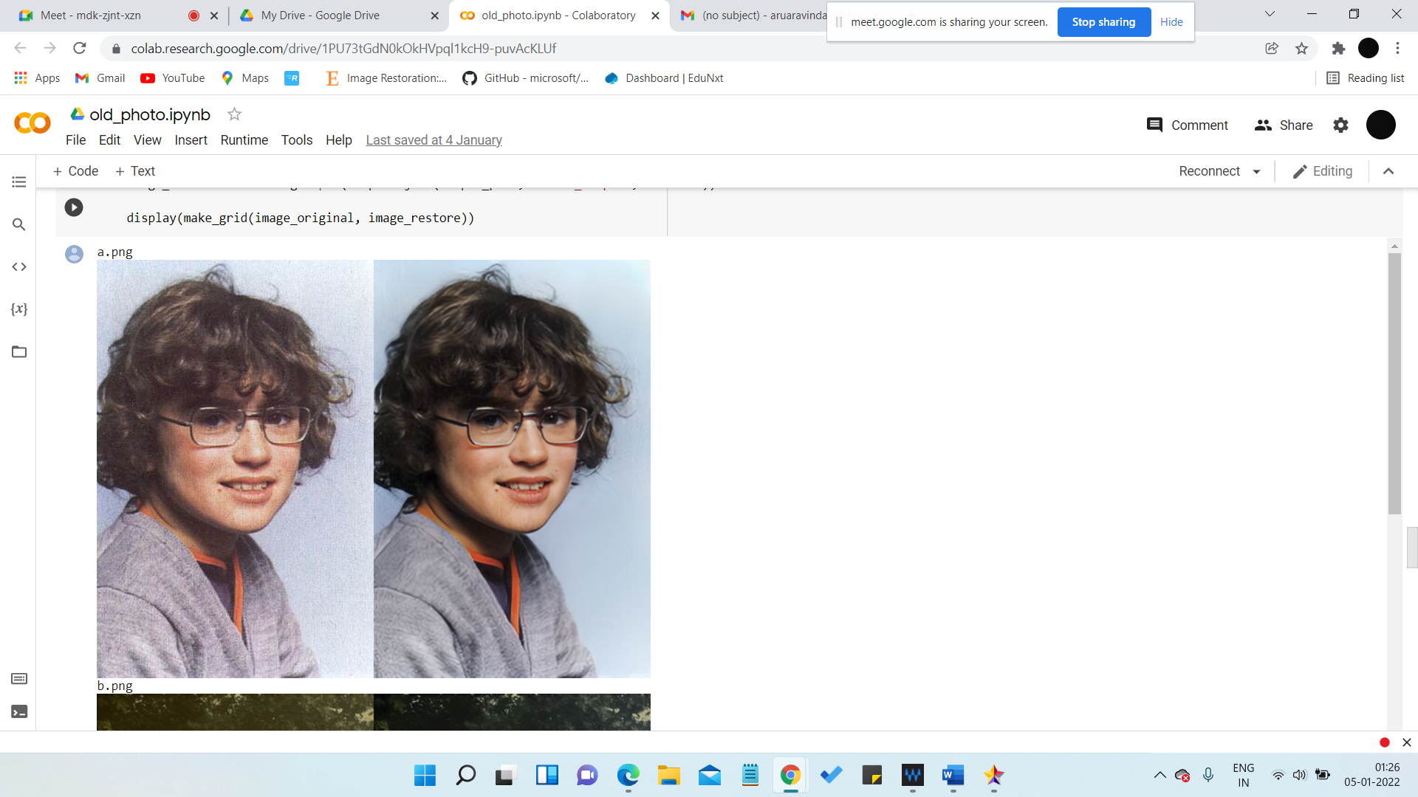

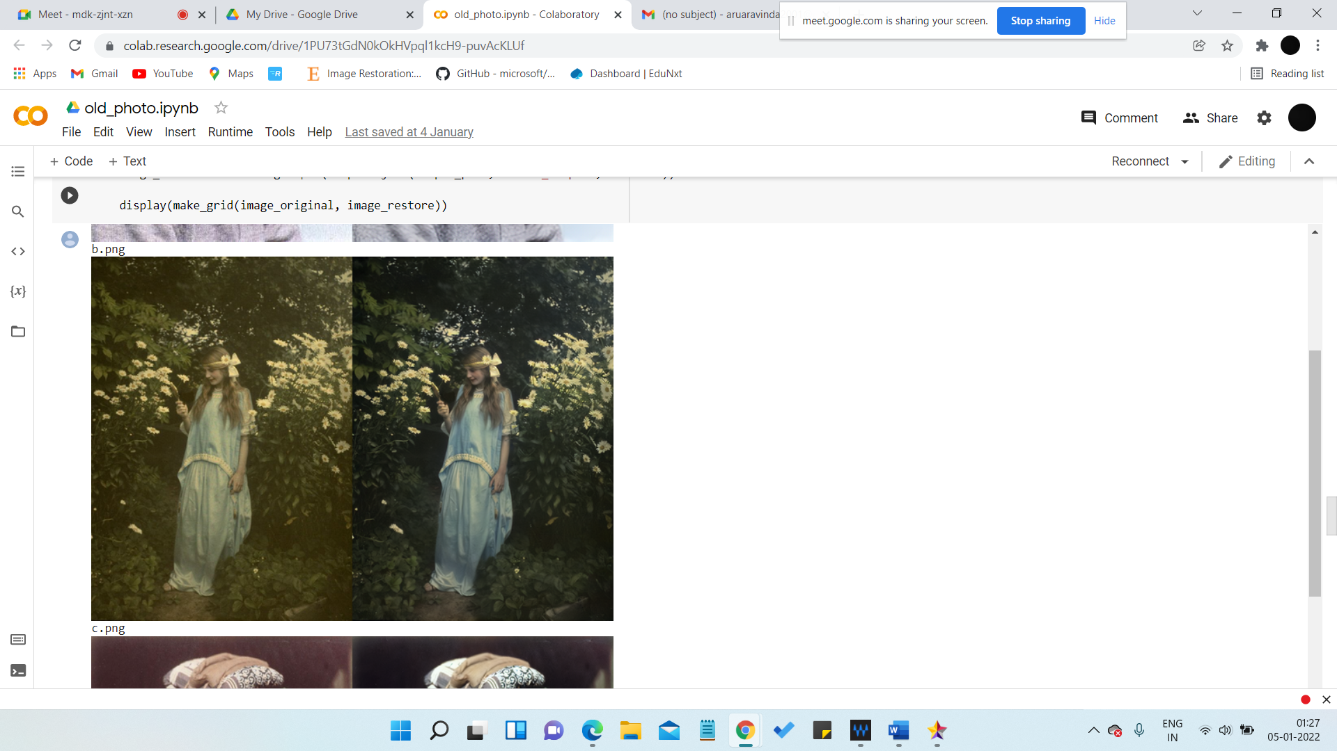

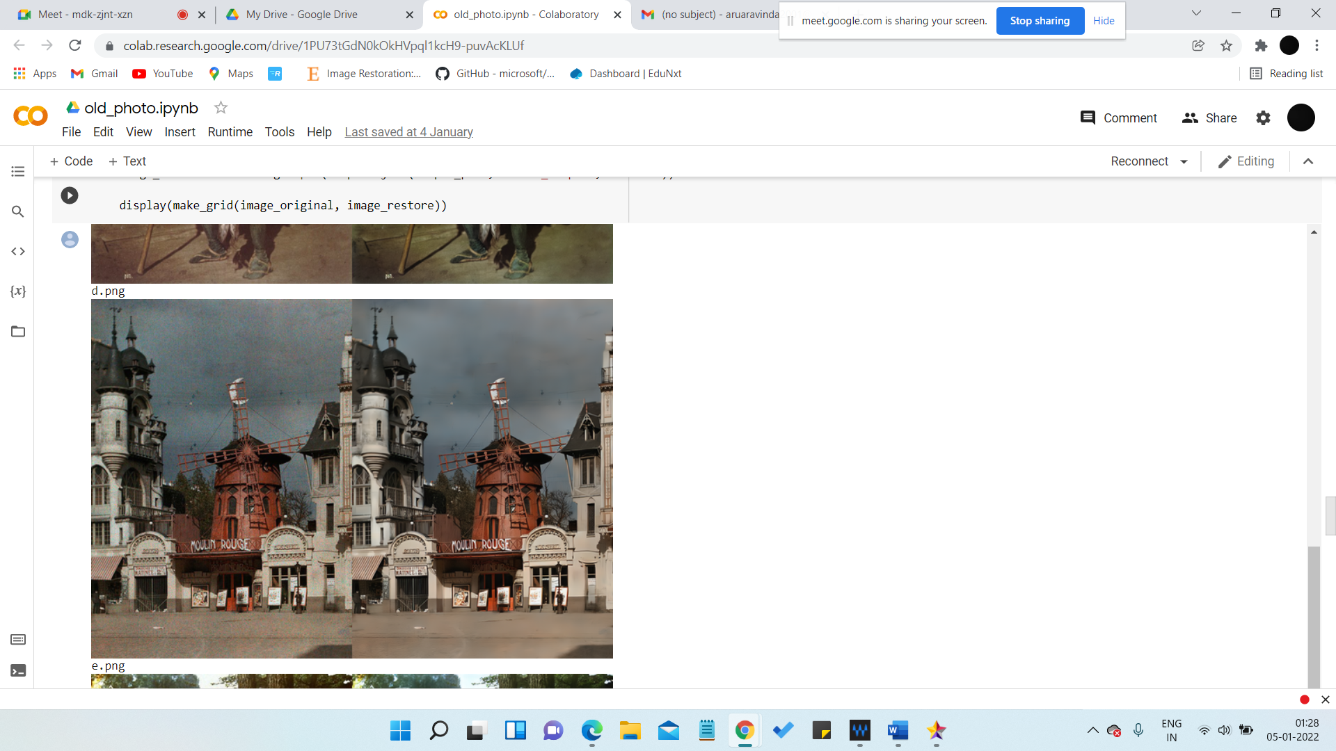

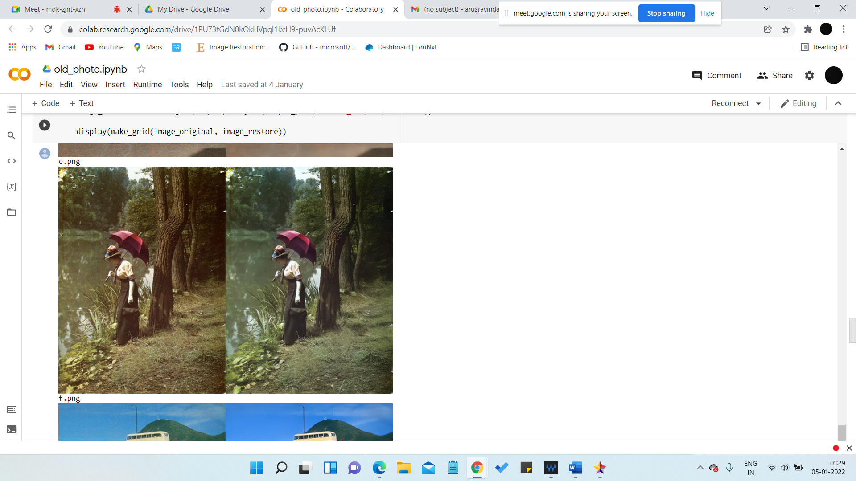

Scratch detection output:

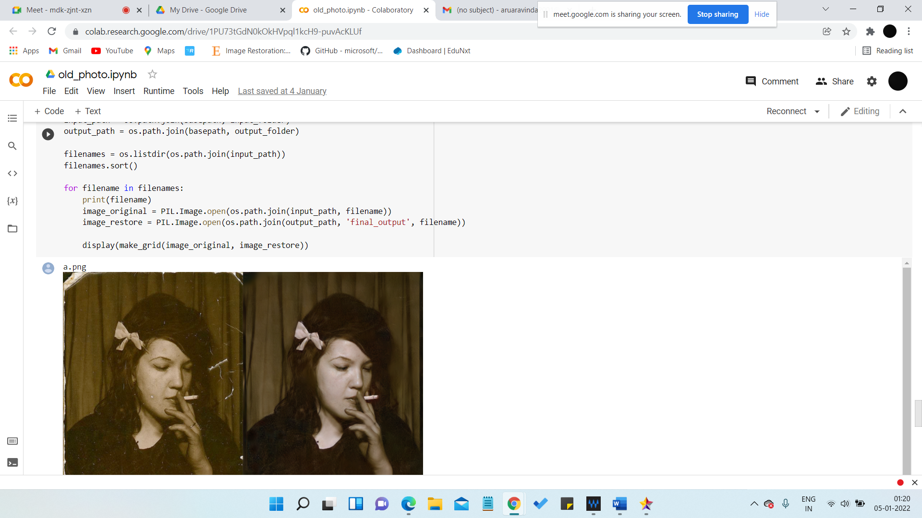

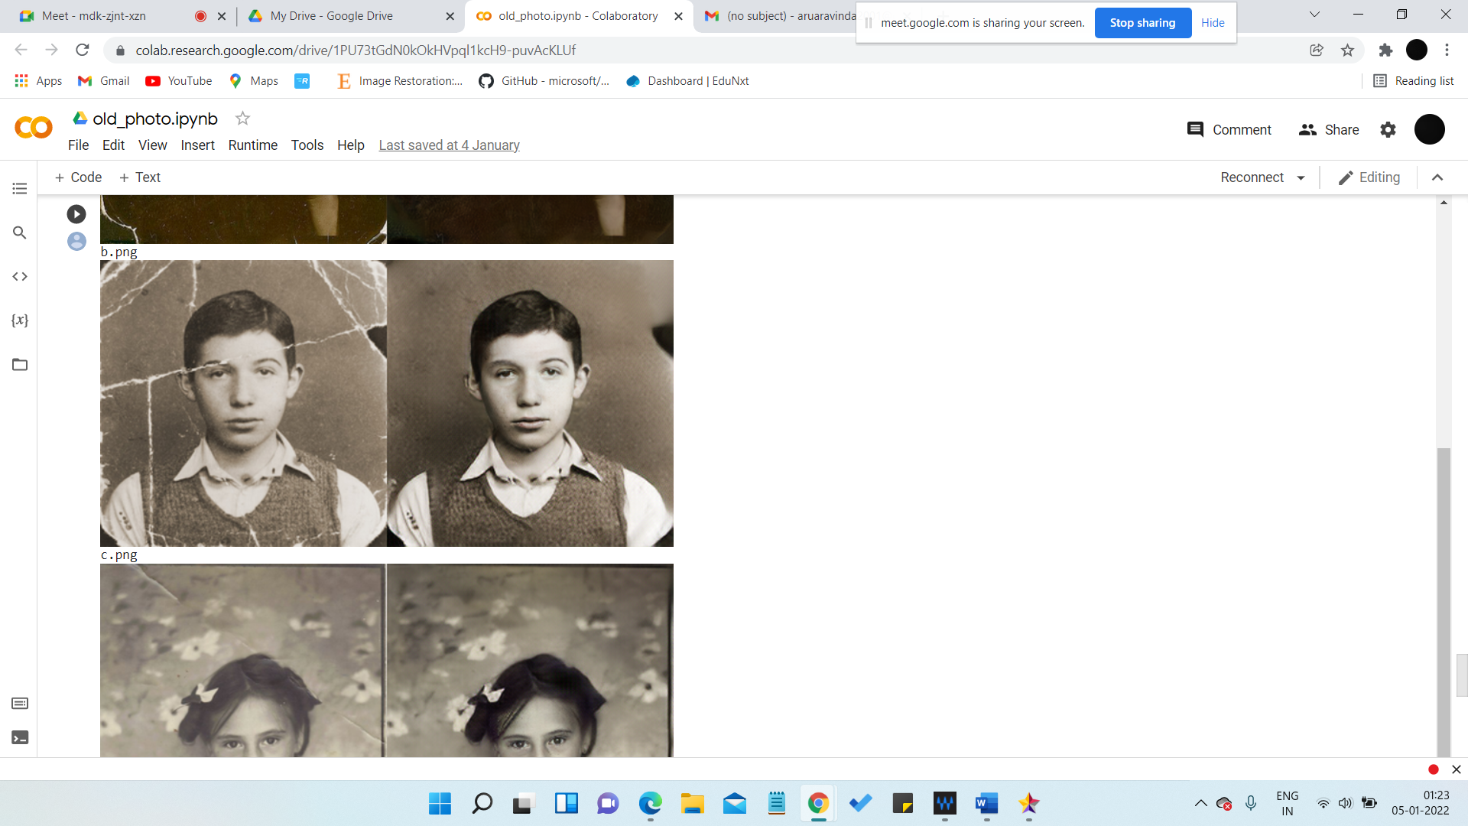

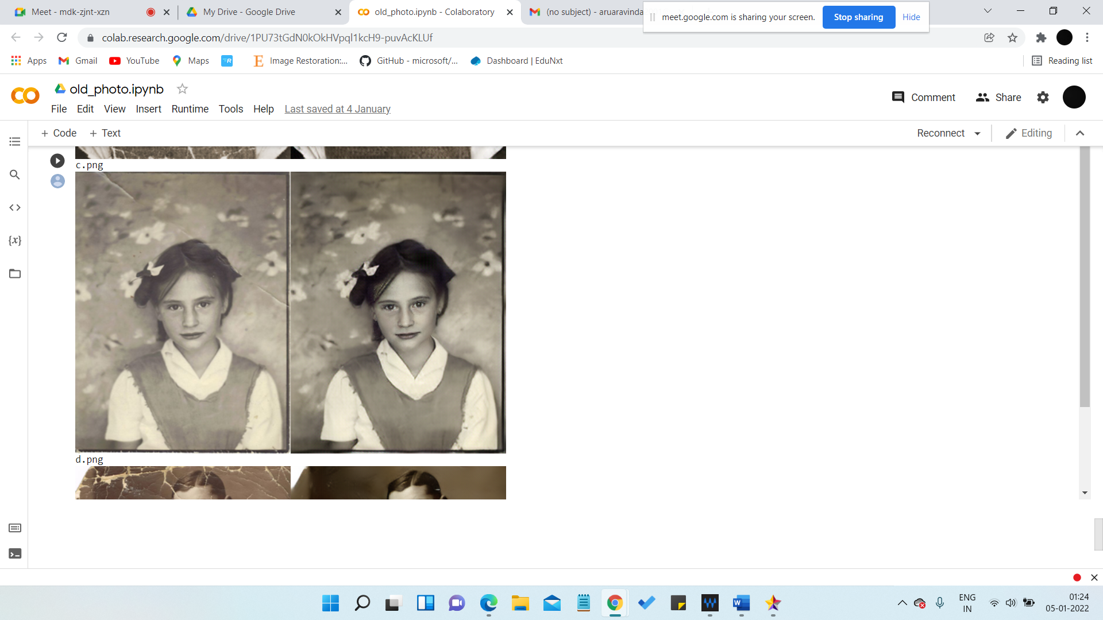

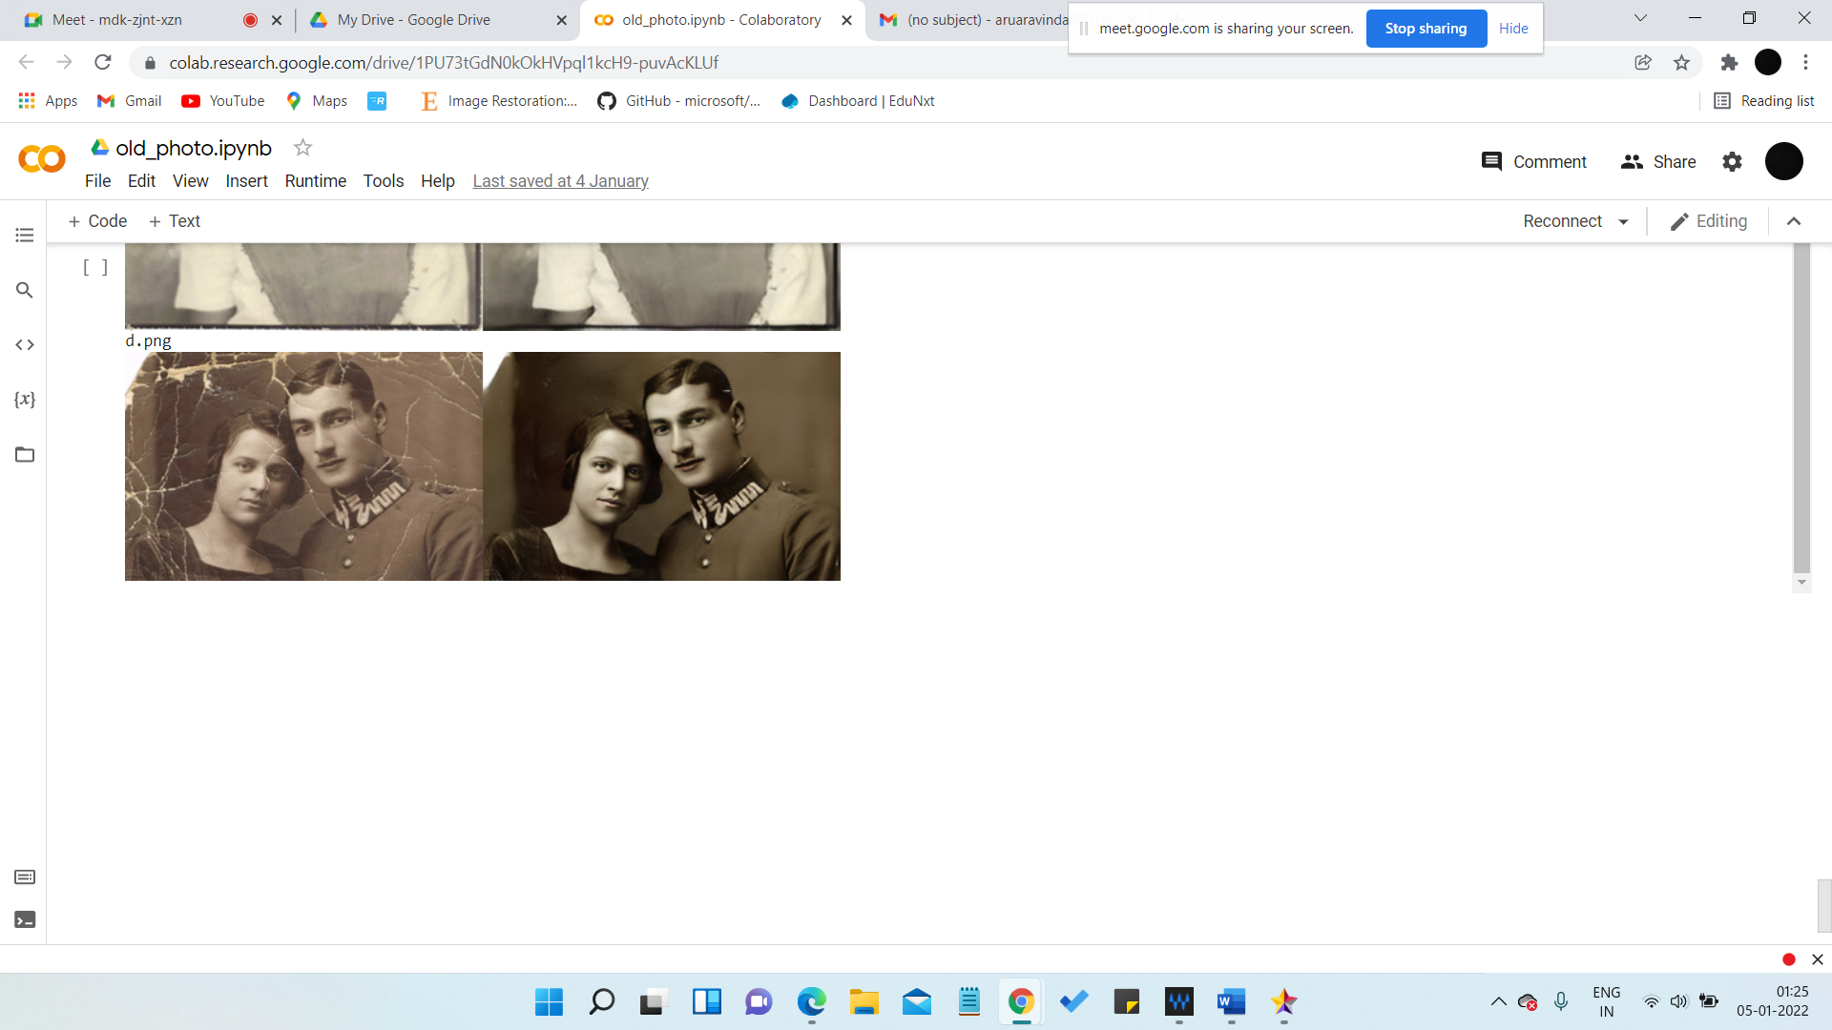

# **References**

1. Noise2Noise: Learning Image Restoration without Clean Data: <https://arxiv.org/pdf/1803.04189.pdf>
2. <https://analyticsindiamag.com/restore-old-photos-back-to-life-using-deep-latent-space-translation-pytorcg-python-demo/>
3. Shrinkage Fields for Effective Image Restoration: <https://openaccess.thecvf.com/content_cvpr_2014/papers/Schmidt_Shrinkage_Fields_for_2014_CVPR_paper.pdf>
4. Image restoration segmentation using watershed method for basic medical applications: <https://ph02.tci-thaijo.org/index.php/past/article/view/244125/165992>
5. IMAGE RESTORATION FUNDAMENTALS AND ADVANCES BY Bahadir k Gunturk and Xin Lee
6. On demand learning for deep image restoration: <http://vision.cs.utexas.edu/projects/on_demand_learning/>
7. Image Restoration using Machine Learning : <http://gpbib.cs.ucl.ac.uk/gp-html/Chaudhry_thesis.html>
8. http://prr.hec.gov.pk/jspui/handle/123456789/4816

**References for Literature Review:**

1. l0TV: A New Method for Image Restoration in the Presence of Impulse Noise <https://ieeexplore.ieee.org/document/7299175>
2. Poisson noisy image restoration via overlapping group sparse and nonconvex second-order total variation priors <https://journals.plos.org/plosone/article?id=10.1371/journal.pone.0250260>
3. Convolutional Neural Network Combined with Half-Quadratic Splitting Method for Image Restoration <https://www.hindawi.com/journals/js/2020/8813413/>
4. Shrinkage Fields for Effective Image Restoration <https://ieeexplore.ieee.org/document/6909751>
5. Noise2Noise: Learning Image Restoration without Clean <https://proceedings.mlr.press/v80/lehtinen18a/lehtinen18a.pdf>